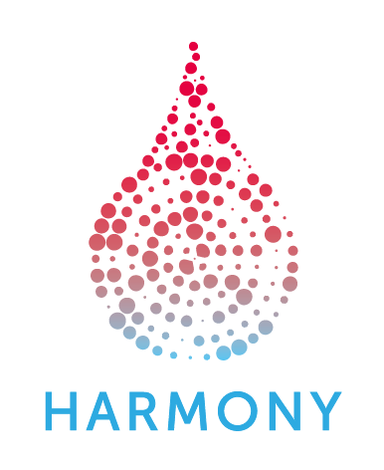
HARMONY 3rd General Assembly 2018

Agenda Thursday, 4th October 2018
Hospital Universitario y Politécnico La Fe (HULAFE).

The HARMONY Steering Committee Meeting is scheduled from 08:30 until 10:25 hrs. Room RRII.

10-13 hrs: Room: Salón de Actos at Hospital La FE (Edificio Dirección, Administración y Docencia (Torre H)

10:00 – 10:25 Registration
10:25 – 10:30 Opening Ceremony
by Dr. Máximo Vento, Scientific Director. Instituto de Investigación Sanitaria La Fe, Valencia, Spain
10:30 – 10:35 Opening and Welcome
by Dr. Guillermo Sanz, Head, Hematology Department & HARMONY co-chair. Hospital Universitario La Fe
10:35 – 11:05 Keynote lecture: HARMONY potential contribution to emerging personalized medicine for the treatment of lymphoproliferative disorders.
by Prof. John Gribben, EHA President Elect. Barts Cancer Institute, London, UK.
11:05 – 11:15 Achievements of HARMONY in the last twelve months
by Prof. Jesús M. Hernández, HARMONY’s Project Coordinator,
Instituto de Investigación Biomédica de Salamanca (IBSAL), Spain
11:15 – 13:00 Core Outcome Set Definition & Preliminary Results in AML. By WP2 and WP6 Leads:
Dr. Lars Bullinger, Charite; Renate Schulze-Rath, Bayer; Jan Geissler, LeukaNet; Hélène Chevrou-Sévérac, Celgene

13:00 – 14:00 Lunch buffet + Filming interviews
14:00 – 16:00 Interactive Parallel Work Package Sessions
WPs | Times | Room | Speakers and Chairs
WP 2 + 6 | 14:00 - 16:00 | H004 | Lars Bullinger, Charite; Renate Schulze-Rath, Bayer  Jan Geissler, LeukaNet; Hélène Chevrou-Sévérac, Celgene
WP 3+4 | 14:00 - 15:00 | H002+3 | Rubén Villoria, GMV; Michel Van Speybroeck, Janssen  Rüdiger Hehlmann, ELN
WP 5 | 14:00 - 15:00 | H005 | Gastone Castellani, UNIBO; Giulia Tonini, Menarini
WP 3+4+5 | 15:00 - 16:00 | H002+3 | Rubén Villoria, GMV; Michel Van Speybroeck, Janssen  Gastone Castellani, UNIBO; Giulia Tonini, Menarini

Ethical Advisory Board Meetings
WP/Group | Times | Room
Ethical Advisory Board + WP8 | 14:00 - 15:00 | H010
Ethical Advisory Board + WP8 + Executive Committee | 15:00 - 16:00 | H010

16:00 – 16:30 Coffee Break + Filming interviews
16:30 – 18:30 Interactive Parallel Hematological Malignancies Sessions
HM | Room | Speakers and Chairs
AML | H004 | Brian Huntly, University of Cambridge; Gert J.Ossenkoppele, VUMC  Francesco Lo-Coco, University Tor Vergata, Rome; Kalitsa Filoussi, Novartis
CLL | H006 | Sarka Pospisilova, Masarykova Univerzita; Thomas Marshall, AbbVie
MDS | H007 | Valeria Santini, University Firenze;  Andrea Kündgen, Heinrich-Heine-University; Alberto Vasconcelos, Celgene
MM | H005 | Felipe Prosper Cardoso, University of Navarra; Mattia D’Agostino, UNITO  Bruno Costa, Celgene
ALL  Pediatric HMs | H008 | Anthony Moorman, Newcastle University; Dirk Reinhardt, GPOH  EFPIA partner tbd

18:30 – 19:30 External Advisory Panel Meeting (by invitation only). Room RRII

20:30 – Networking dinner
